Chapter 7

Snapshots

7.1 User Login

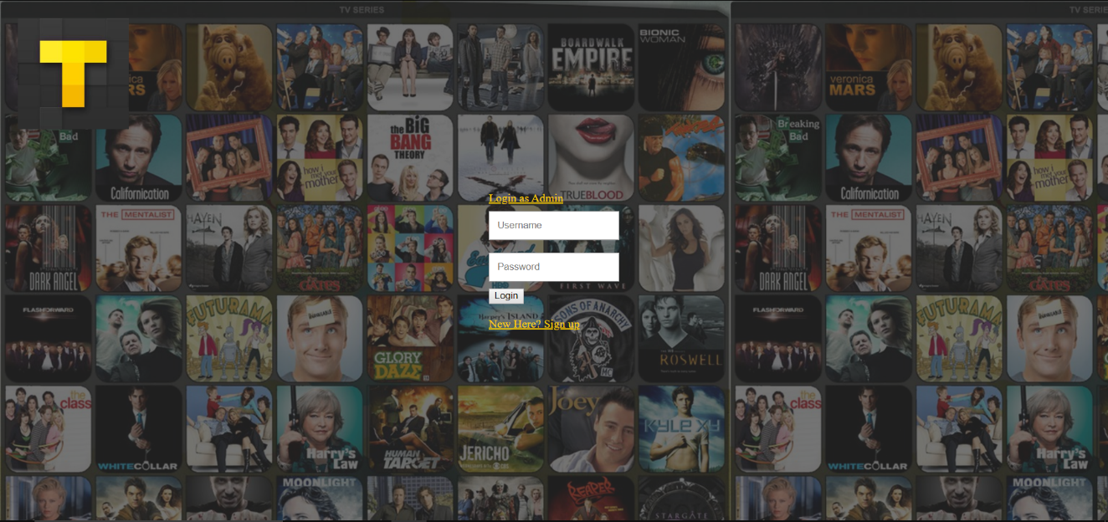

Figure 7.1 – User Login

7.2 Registration

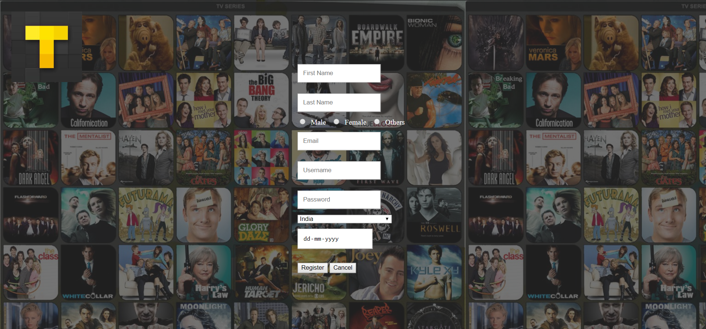

Figure 7.2 – Registration

7.3 Admin Login

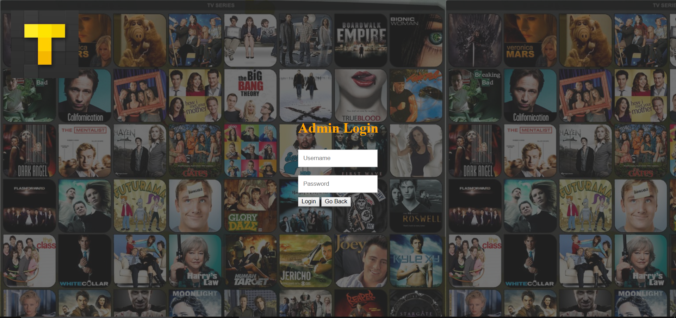

Figure 7.3 – Admin Login

7.4 Dashboard

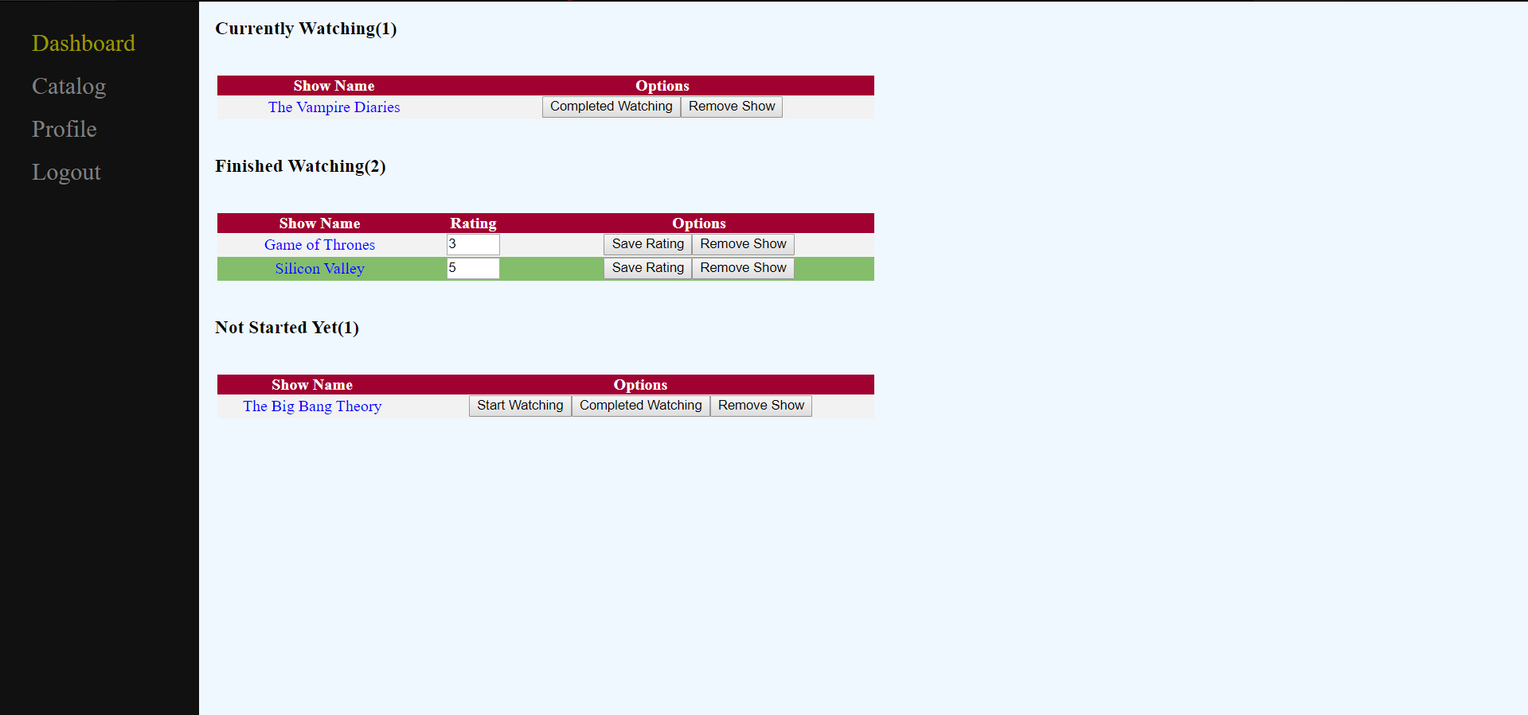

Figure 7.4 – Dashboard

7.5 User Catalog

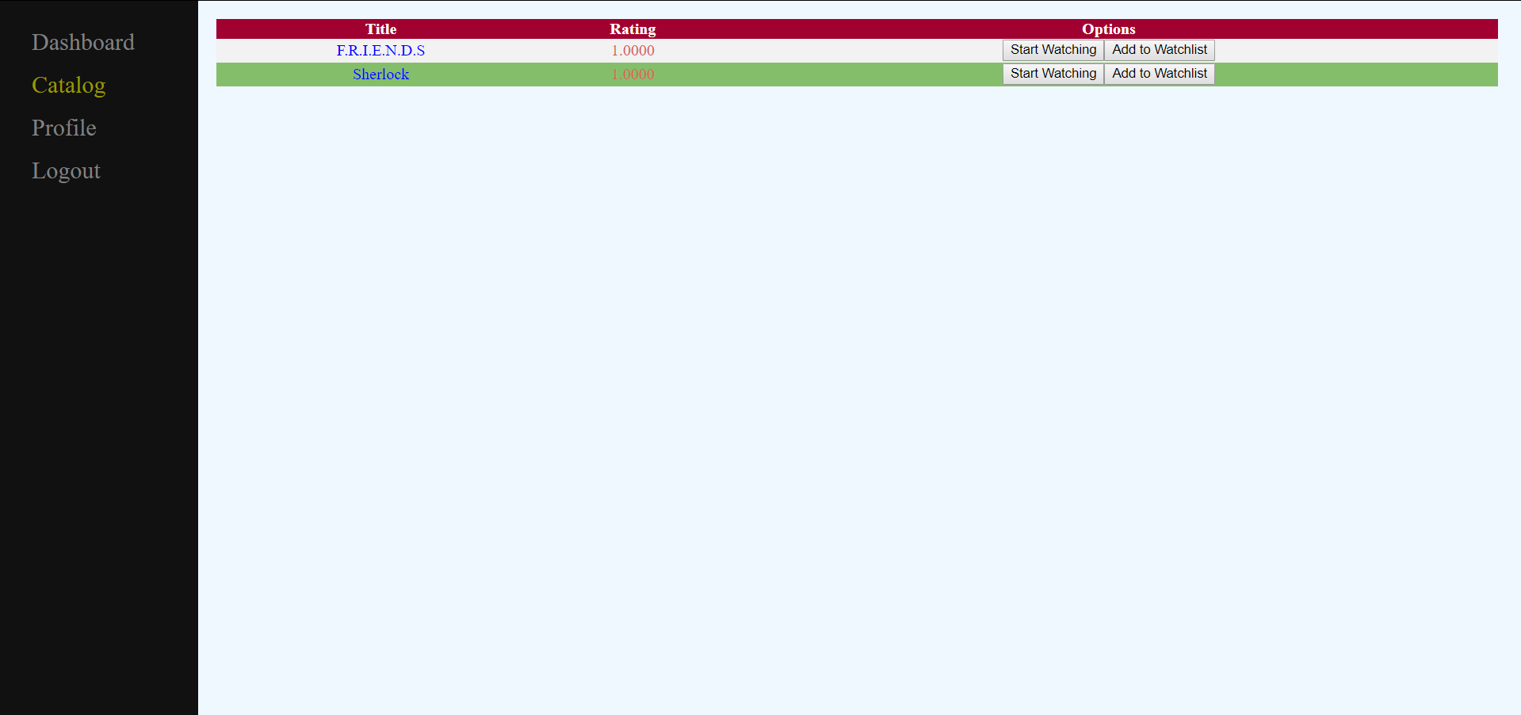

Figure 7.5 – User Catalog

7.6 Profile

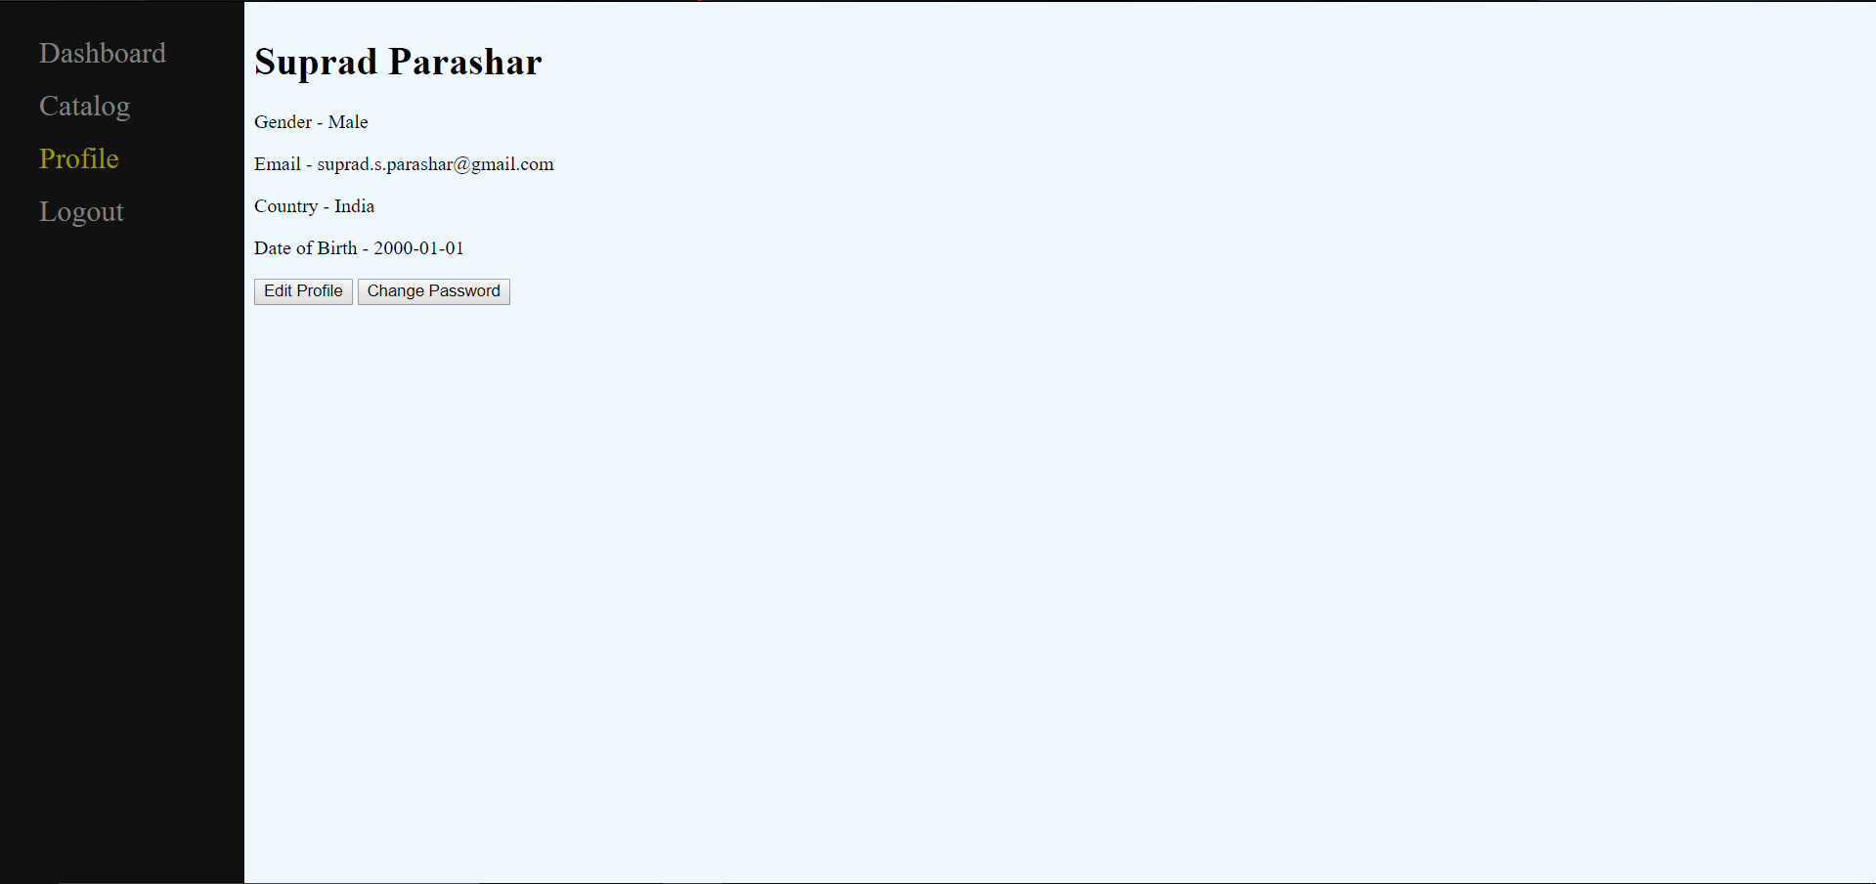

Figure 7.6 – Profile

7.7 Show Details

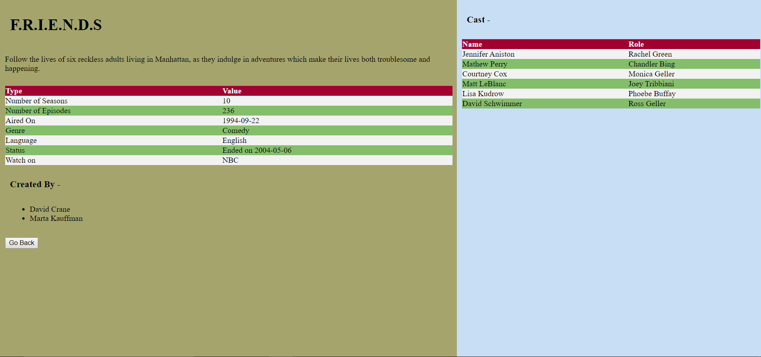

Figure 7.7 – Show Details

7.8 Users (Admin)

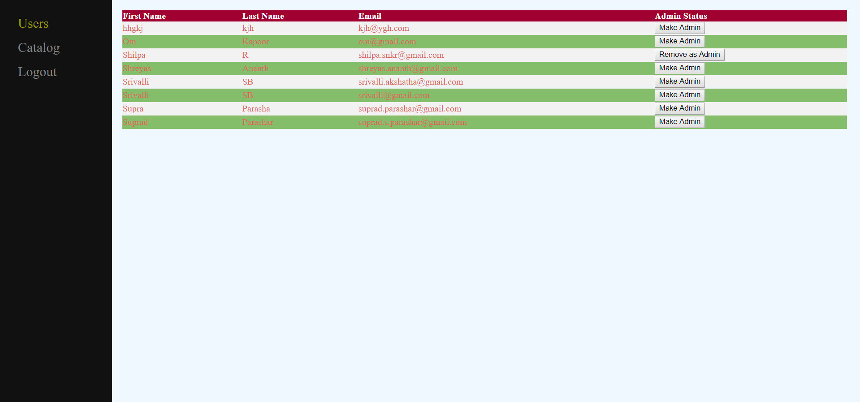

Figure 7.8 – Users (Admin)

7.9 Catalog (Admin)

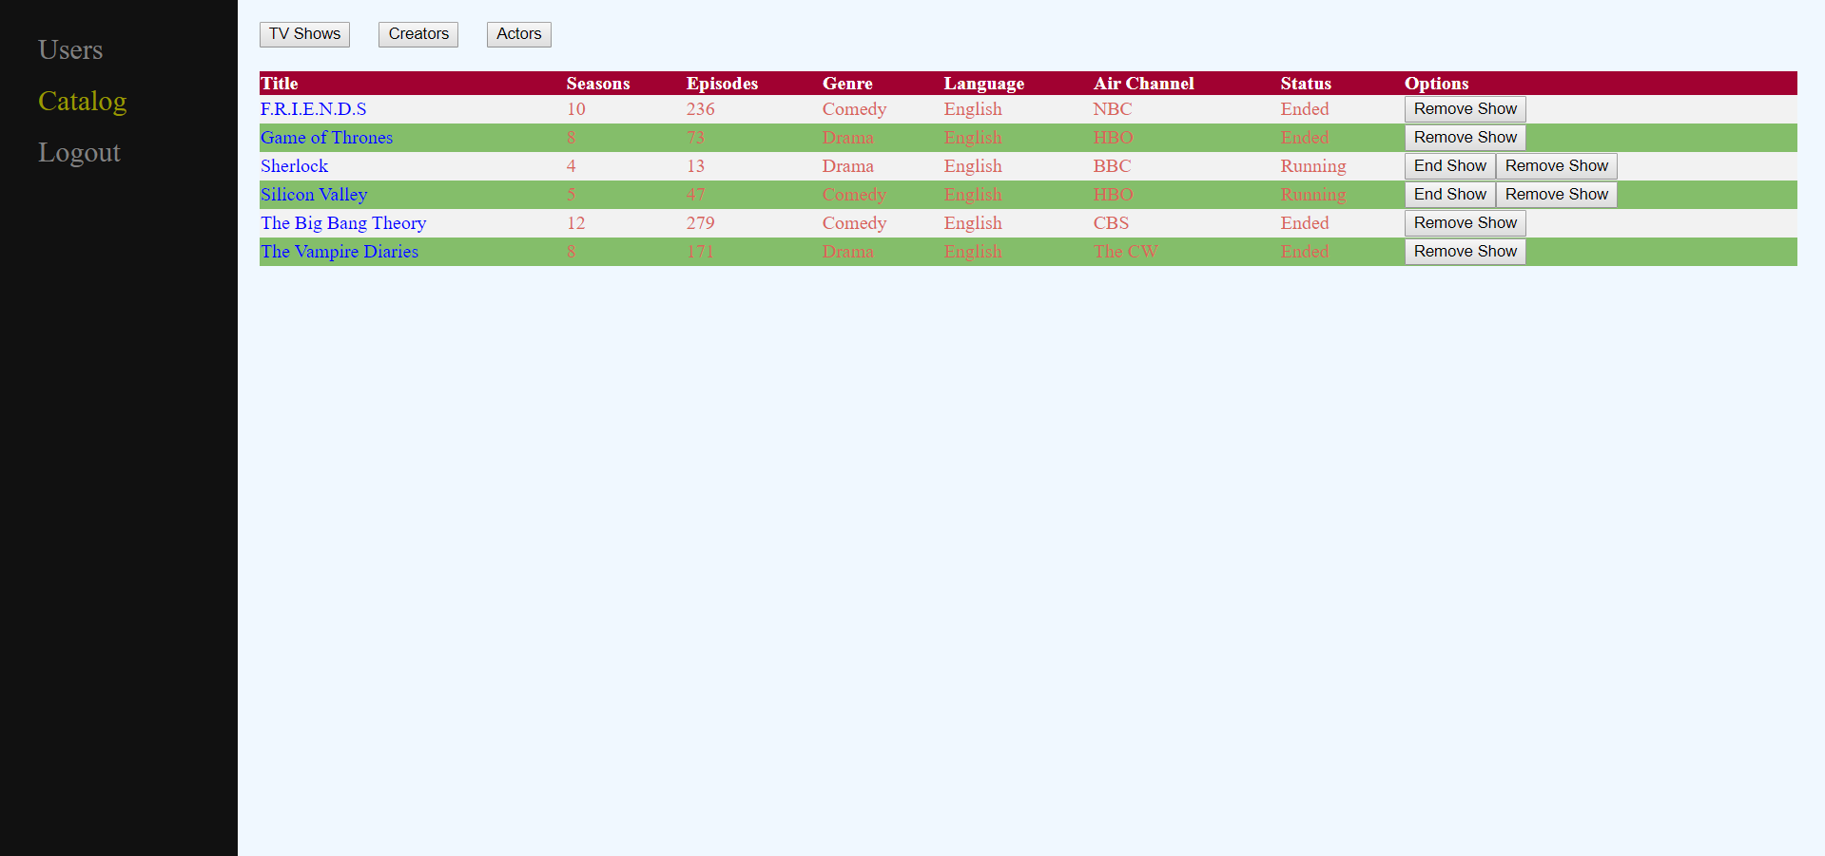

Figure 7.9 – Catalog (Admin)

7.10 Add TV Shows (Admin)

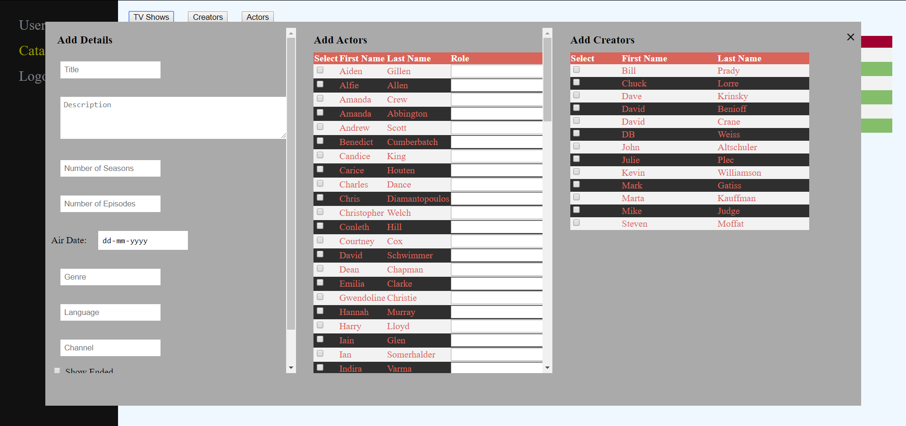

Figure 7.10 – Add TV Shows (Admin)

7.11 Add Creators (Admin)

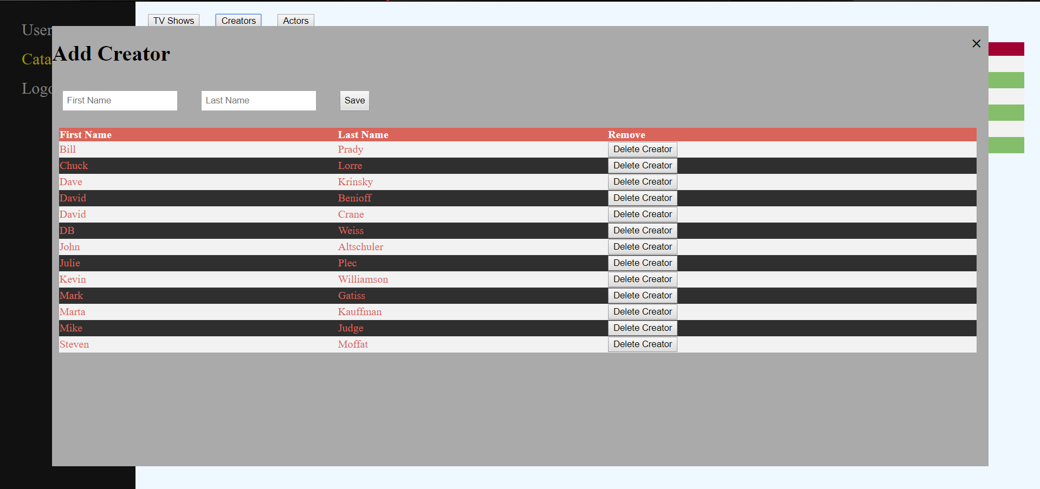

Figure 7.11 – Add Creators (Admin)

7.12 Add Actors (Admin)

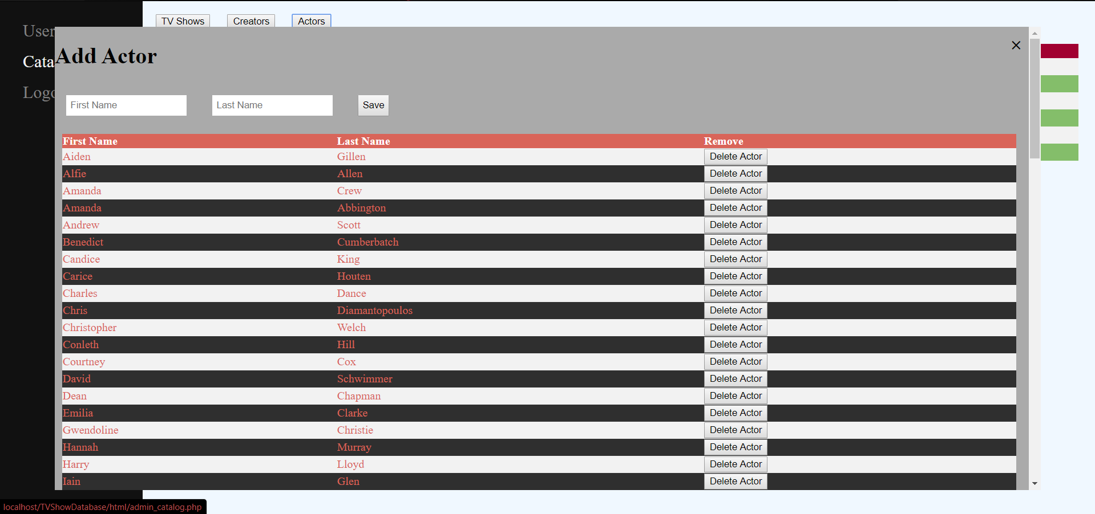

Figure 7.12 – Add Actors (Admin)

7.13 Edit Show (Admin)

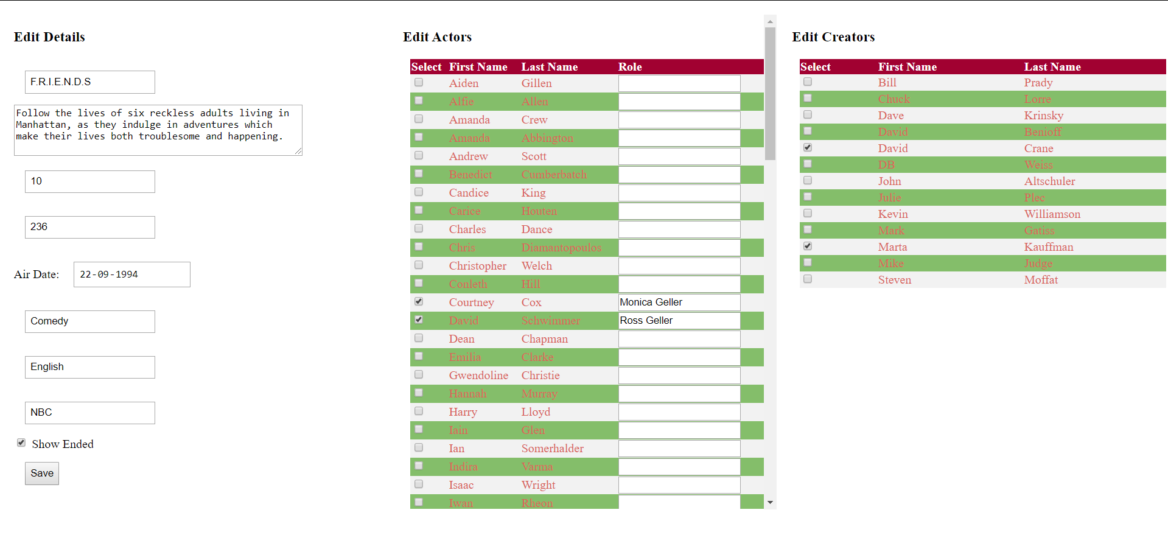

Figure 7.13 – Edit Show (Admin)